**Sample App Evaluation Report**

**App Name**: My Chat App (Voice & Video Calling and Text Chat App for Kotlin)

**Date of Evaluation**: 28/04/2024

**Evaluator**: Ayush Verma

**1. Introduction:**

This report documents the evaluation of My Chat App (Voice & Video Calling and Text Chat App for Kotlin), a sample app provided by CometChat. The evaluation includes an assessment of the app's functionality, any encountered errors, and overall user experience.

**2. App Running Status:**

The sample app ran smoothly without any major issues. The functionality of the app performed as expected, and all features were accessible.

**3. Issues Encountered:**

AGP Compatibility Issue: At the beginning of the evaluation, there was an issue related to AGP (Android Gradle Plugin) compatibility. However, this issue was quickly identified and resolved by updating the necessary dependencies.

**4. Evaluation of UI and Functionality:**

The user interface of the app was intuitive and easy to navigate. Key features, such as the "Conversations with Messages" component, functioned as intended and provided a seamless user experience.

**5. Recommendations:**

Based on the evaluation, no significant recommendations are required as the app performed well without encountering any major issues. However, it is always beneficial to continue monitoring and updating dependencies to ensure compatibility with the latest frameworks and libraries.

**6. Conclusion:**

Overall, the evaluation of My Chat App (Voice & Video Calling and Text Chat App for Kotlin), resulted in a positive outcome. The app demonstrated stable functionality with no critical issues encountered during the testing process. Any initial compatibility issues were promptly addressed, highlighting the responsiveness of the development team.

**Screenshots:**

1.Screenshot 1:

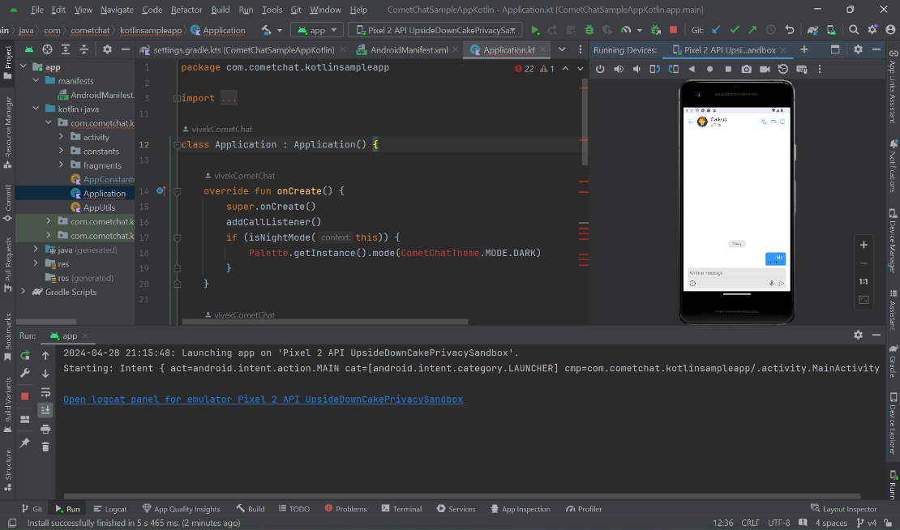

2. Screenshot 2:

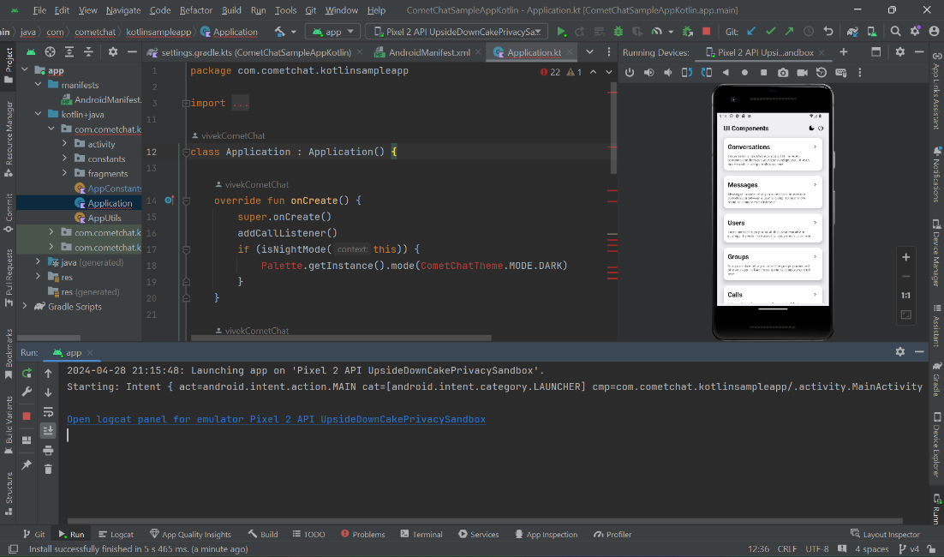

This concludes the evaluation report for My Chat App. If you have any further questions or require additional information, please feel free to contact the evaluator.

Thank you.

Ayush Verma,

ayushuv135@gmail.com,

28/04/2024